**Exercise List for hip replacement**

1. Standing Hamstring curls

Position: Prone, standing Targets: Strengthening of hamstrings; biceps femoris, semitendinosus, semimembranosus. Add cuff weights to increase resistance. Instruction: Prone: Patient lies flat on stomach and brings heel toward buttock, keeping neutral hip rotation (A). Patient may turn hip outward, externally rotating 45 degrees to target lateral hamstring (bicep femoris) (B) or inward, internally rotating 45 degrees to target medial hamstrings (semitendinosus, semi-membranosis) (C). Patient can also do this while squeezing a weighted ball between the ankles to add resistance and hip work. Standing: Patient holds onto stable object in front and brings heel toward buttocks keeping neutral hip rotation (D). Substitutions: Maintain neutral pelvis; active lower abdominal core encouraged; thighs stay in alignment with each other. Parameters: 8 to 12 repetitions, 1 to 3 sets, 1 time per day.

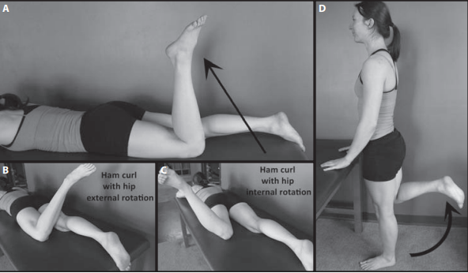

1. Standing hip abduction

Position: standing

Targets: Mobility of the hip

Instruction: In standing, patient may hold chair or table for balance as patient abducts the hip, keeping hip and knee extended to 0 degrees and toes pointing forward.

Repeat 10 to 20 times, 1 to 3 times per day

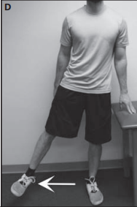

1. Heel slide

Position: Supine, seated Targets: Mobility of the hip into flexion and extension Instruction: Supine: Patient slides the affected heel toward buttocks as he or shelm bends the knee. Hold a gentle stretch in this position and then return to fully extended.

Seated: Patient sits on front half of chair and slides target side heel back under chair to bend knee as far as possible, holds for gentle stretch, and then extends knee fully, keeping heel on floor. Repeat

Substitutions: Pelvic or trunk movement; hip, knee, and ankle stay in alignment in sagittal plane. Parameters: Hold for 5 to 10 seconds, 10 to 20 repetitions, repeat 1 to 3 times per day.

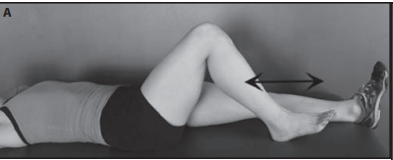

1. Side Straight leg raise

Position: Side-lying, standing Targets: Mobility of the hip in coronal plane Instruction: Patient lies on unaffected side with hip and knee extended to 0 degrees and lifts leg toward ceiling, keeping toes pointed straight forward. Hold 1 to 2 seconds and return (A and B).

Substitutions: Patient flexes or extends hip, rolls trunk forward or backward in sidelying; does not keep toes pointed straight ahead (adding rotation). The bottom leg can be bent to help stabilize body. Parameters: Repeat 10 to 20 times, 1 to 3 times per day.

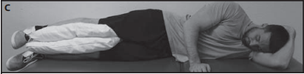

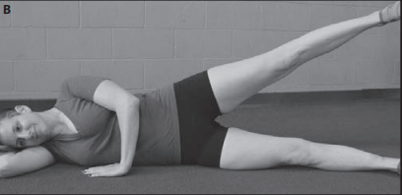

1. Standing wall squats

Position: Standing

Targets: Strengthening of hip extensors gluteus maximums, hamstrings, and quadriceps, extending the knee

Instruction: Wall squat: Patient crosses arms and leans back against wall with feet hip-width apart and patella lined up with second toes of feet, which are pointed forward. Patient slides down wall to 90-degree bend at hips and knee. Patient should still be able to see toes in front of knees. Patient then rises back up and repeats.

Substitutions: Maintain neutral pelvis; active lower abdominal core encouraged, knee stays directly aligned with hip and behind toes. Parameters: 8 to 12 repetitions, 1 to 3 sets, 1 time per day.

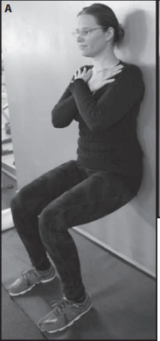

1. Standing hip flexion and extension

Position: Standing Targets: Mobility of the hip

Instruction: Patient standing with unaffected side near table or wall using hand to balance brings affected hip into extension, followed by flexing hip and knee as if marching in place with only the one leg (A and B). Substitutions: Knee falls in or out Parameters: Repeat 10 to 20 times, 1 to 3 times per day.

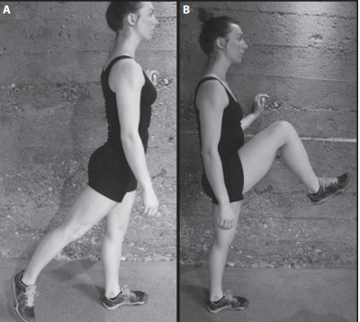

1. Bridging

Position: Hook-lying Targets: Strengthening of hip extensors; gluteus maximus primarily with assist from hamstrings. Instruction: Bridge: Patient with knees and feet hip-width apart tightens lower abdominals and lifts hips up off table until extended to 0 degrees, pelvis should be level (A and B)

Substitutions: Maintain neutral spine and pelvis; active core encouraged, do not arch back. Parameters: Hold 1 to 2 seconds, 8 to 12 repetitions, 1 to 3 sets, 1 time per day or every other day.

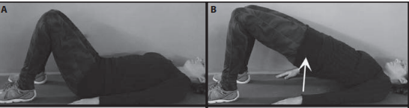

1. Step downs

Position: Standing

Instructions: Lateral: Patient stands on the edge of a 15-cm step on the target leg and squats slowly to lower the heel of the non-target leg toward floor for one count and then returns to start position during the next count.

Substitutions: Maintain neutral pelvis; active lower abdominal core encouraged, knee on target side stays directly aligned with hip and behind toes, focus on keeping hips and knee still and as controlled as possible. Parameters: 8 to 12 repetitions, 1 to 3 sets, 1 time per day

